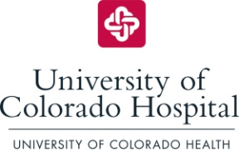

Nursing Career Map© SBAR

Situation:
Research demonstrates engaged employees experience higher job satisfaction.

Background:
Nursing staff may be unaware of the various roles and/or areas of opportunity in which to become further engaged, either while remaining in their current role or while looking to advance their career within the organization.

Assessment:
The Nursing Career Map was created to provide leadership with a tool to increase awareness and enhance nurses’ identification of professional growth opportunities at UCH.

The map is structured around the Magnet Model© Components of Transformational Leadership, Structural Empowerment, Exemplary Professional Practice, and New Knowledge, Innovations & Improvements; in addition to Quality & Patient Safety.

Courses offered through the Departments of Professional Resources and Human Resources and are depicted on the back of the map. These courses are examples of educational offerings which support the respective areas on the front of the map.

Recommendation:
Utilize the Nursing Career Map during annual performance reviews, and as needed, to help set goals and discuss professional growth opportunities with staff. The tool is meant to serve as a stepping stone to assist leaders with having conversations related to engagement and professional growth. Staff are encouraged to check the HUB for current course information.

